Introduction

Blockchain began with Bitcoin in 2008, but it has come a long way from its cryptocurrency roots. Initially known for its decentralized nature, transparency, and security, blockchain has since revolutionized the financial industry. It now supports a variety of financial instruments, including distributed applications (dApps), smart contracts, and decentralized finance (DeFi), all of which eliminate middlemen and businesses. Therefore, it simplifies and democratizes the global financial system. Blockchain has many important applications, including crossborder payments, financial transactions, and asset tokenization.
It also increases the stability and performance of real assets. Despite early success, some obstacles remain to overcome, such as major challenges to blockchain integration and lack of government regulation. However, the future is promising with new technologies such as artificial intelligence (AI) and the Internet of Things (IoT). At its current pace, blockchain could eventually change how business is done in the financial sector. This article explores how blockchain can transform financial markets beyond cryptocurrencies. We also explore the disadvantages faced by blockchain and discuss its needs.

Problem Definition

Blockchain technology was developed to aid in cryptocurrency transactions, which have been customized on a grand scale to find applications in other financial systems. Its great promise to increase transaction transparency, decrease cost, and eliminate an intermediary has not yet fulfilled itself in many financial services other than crypto, mainly due to various unavoidable and imminent challenges, including scalability issues, regulatory uncertainty, and security vulnerabilities even in areas such as DeFi (decentralized finance) and asset tokenization. This paper would like to address how this technology can change traditional financial activities and identify obstacles that should be avoided to enable wide-scale integration.

Motivation, Objective and Social Relevance

- Motivation
Expand Beyond Cryptocurrency: Examine how blockchain technology could potentially extricate itself from a range of native digital currencies to introduce or revitalize a malaise of existing financial applications.
Identify Barriers to Adoption: Understand the existent regulatory, scalability, and security issues pertaining to the limited integration of blockchain technology in traditional financial systems.
Emphasize Technological Advancements: Ongoing research and development are vital to effectively use the capabilities of blockchain in making financial transactions efficient and secure.
- Social Relevance
Promote Financial Inclusivity: Blockchain must be promoted as a measure to alter the traditional financial services landscape and provide access to financial services for underbanked and unbanked populations, thereby reducing their dependency on traditional banking institutions.
Enhance Transaction Transparency: Expound how the immutable ledger of blockchain creates a platform for trust and transparency in financial transactions, which are necessary for user confidence and market integrity.
Drive Economic Empowerment: Within the broader context, explores the possibility of using blockchain to create efficiency in Trade and Finance and to develop the economic justice and empowerment of marginalized communities.
- Objective
- To study Decentralized Finance (DeFi)
- To explore the Use Cases of DeFi
- To study the Challenges and Risks in DeFi
- To understand Blockchain Architecture
1.3 Planned Outcome

- Comprehensive Understanding of Blockchain Applications: Understand more about blockchain technology applied in such broader financial contexts like decentralized finance (DeFi), supply chain finance, and asset tokenization.

- Assessment of Benefits and Limitations: Analyze blockchain technology's benefits, specifically enhanced efficiency, transparency, and security, while also identifying its limitations like scalability issues and regulatory challenges.

- Case Study Evaluations: Examine current security measures in blockchain applications, including cryptographic techniques, consensus algorithms, and possible vulnerabilities, to suggest improvements.

- Exploration of Security Frameworks: To examine current security measures in their implementation of blockchain applications concerning cryptographic techniques, consensus algorithms, and possible vulnerabilities, to also put forth improvement recommendations.

- Future Research Directions: Suggest areas for future research, focusing on improving scalability, interoperability, and the integration of blockchain with emerging technologies like AI and IoT.

- Social and Economic Implications: Discuss the social relevance of blockchain technology in promoting financial inclusivity, enhancing transaction transparency, and driving economic empowerment in underserved communities.

- Strategic Recommendations for Adoption: Provide actionable insights and strategic recommendations for stakeholders and policymakers to facilitate the broader adoption of blockchain technology in financial sectors while addressing regulatory concerns.

Literature Survey of Topic

Table No. I: Literature Survey Table

Sr. No | Title & Author | Conference/Journal Name & Publication Year | Topic Reviewed/Algorithms or Methodology Used | Advantages & Disadvantages
1 | Title: 'The Role of Blockchain in Finance Beyond Cryptocurrency: Trust, Data Management, and Automation.'  Author: Chen, Hanfang, et al. | IEEE Access (2024) | Blockchain in finance, focusing on trust, data management, and automation beyond cryptocurrency | Advantage: Enhanced trust, improved data handling, and automation across financial systems.  Disadvantage: Scalability and regulation issues remain challenging.
2 | Title: 'A survey on blockchain technology: Evolution, architecture and security.'  Author: Bhutta, Muhammad Nasir Mumtaz, et al. | IEEE Access 9 (2021) | Survey on blockchain technology, evolution, architecture, and security techniques | Advantage: Comprehensive overview of blockchain evolution and security aspects. Disadvantage: Some emerging areas, such as quantum threats, are not deeply analyzed.
3 | Title: 'Blockchain as a general-purpose technology: Patentometric evidence of science, technologies, and actors.'  Author: Ozcan, Sercan, and Serhan Unalan | IEEE Transactions on Engineering Management 69.3 (2020) | Patentometric analysis of blockchain as a general-purpose technology | Advantage: Insight into blockchain patents and its wide-ranging technological applications.  Disadvantage: Patent analysis might overlook unpatented innovations.
4 | Title: 'A new era of blockchain-powered decentralized finance (DeFi)-a review.'  Author: Dos Santos, Saulo, et al. | 2022 IEEE 46th Annual Computers, Software, and Applications Conference (COMPSAC) | Review of decentralized finance (DeFi) powered by blockchain | Advantage: Highlights potential of DeFi to disrupt traditional finance, increased transparency.  Disadvantage: Vulnerabilities in smart contracts and regulatory uncertainties.
5 | Title: 'Defi-ning defi: Challenges & pathway.'  Author: Amler, Hendrik, et al. | 2021 3rd Conference on Blockchain Research & Applications for Innovative Networks and Services (BRAINS) | Challenges and future pathways of decentralized finance (DeFi) | Advantage: Identifies key challenges in DeFi, offers solutions for scalability and security.  Disadvantage: Unresolved security risks and regulatory compliance issues remain.
6 | Title: 'Blockchain security: A survey of techniques and research directions.'  Author: Leng, Jiewu, et al. | IEEE Transactions on Services Computing 15.4 (2020) | Survey of blockchain security techniques and future research directions | Advantage: Extensive coverage of blockchain security methods, including encryption and consensus. Disadvantage: Limited focus on emerging threats, like post-quantum cryptography.
7 | Title: 'A Secure and Flexible Blockchain-Based Offline Payment Protocol.'  Author: Jie, Wanqing, et al. | IEEE Transactions on Computers (2023) | Blockchain-based offline payment protocol | Advantage: Enhances flexibility and security in offline transactions. Disadvantage: Scalability issues and potential vulnerability during reconnection.
8 | Title: 'DeFiScanner: Spotting DeFi attacks exploiting logic vulnerabilities on blockchain.'  Author: Wang, Bin, et al. | IEEE Transactions on Computational Social Systems 11.2 (2022) | DeFi attack detection using logic vulnerability scanning | Advantage: Improved detection of DeFi attacks, enhancing security in blockchain ecosystems. Disadvantage: Limited applicability to certain DeFi protocols.
9 | Title: 'Securing deployed smart contracts and DeFi with distributed TEE cluster.'  Author: Li, Zecheng, et al. | IEEE Transactions on Parallel and Distributed Systems 34.3 (2022) | Smart contract and DeFi security using Trusted Execution Environments (TEE) clusters | Advantage: Strengthens DeFi and smart contract security using TEE clusters. Disadvantage: Limited scalability and high computational overhead.
10 | Title: 'PETchain: A blockchain-based privacy enhancing technology.'  Author: Javed, Ibrahim Tariq, et al. | IEEE Access 9 (2021) | Blockchain-based Privacy Enhancing Technology (PETchain) | Advantage: Enhances privacy in blockchain applications using PETs.  Disadvantage: Computational cost and complexity in maintaining privacy features.

Discussion of Base Paper

- General Overview of Blockchain Technology: This paper will outline how blockchain evolved from a framework for a cryptocurrency into a flexible solution for different financial applications. Moreover, blockchain provides a decentralized, secure, and transparent environment for transactions, in addition to enhancing the trust and efficiency associated with financial operations.
- Core Principles of Blockchain: The three most important core principles associated with blockchain technology are decentralization, immutability, and transparency. They eliminate the need for intermediaries, ensure that once data is recorded no one can modify the information without a consensus, and every participant on the network can see a history of transactions, thus encouraging trust and accountability.
- Potential Applications in Finance: The key applications of blockchain in the financial industry, such as smart contracts to automate transactions, supply chain financing to increase transparency, and identity management to minimize fraud, are all given examples of how blockchain streamlines operations, cuts costs, and enhances data security in this paper.
- Impact on Financial Industries: Blockchain technology is poised to revolutionize various financial industries by improving efficiency, reducing transaction times, and lowering operational costs. In banking, blockchain can facilitate cross-border payments.

- Barriers to Adoption: The paper acknowledges significant barriers to the widespread adoption of blockchain, including regulatory uncertainty, lack of interoperability between different blockchain systems, and the need for substantial investment in infrastructure. These challenges hinder the integration of blockchain solutions into existing financial frameworks.
- Future Prospects of Blockchain: The future of blockchain in finance is characterized by ongoing innovation and integration into traditional financial systems. Continuous research is needed to address scalability issues, enhance user experience, and develop standards for interoperability. Collaboration between industry stakeholders, policymakers, and technologists is crucial for driving blockchain adoption.
- Importance of Research and Ethical Considerations: The importance of ongoing research in blockchain technology is emphasized, particularly regarding its ethical implications. Understanding the societal impact of blockchain can guide its responsible deployment, ensuring that it benefits all stakeholders. A comprehensive research framework is essential for addressing challenges and leveraging blockchain’s potential for positive change in financial services.
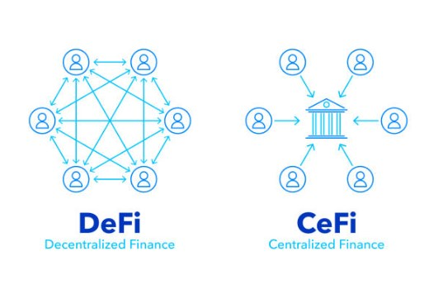

Fig.1: DeFi & CeFi

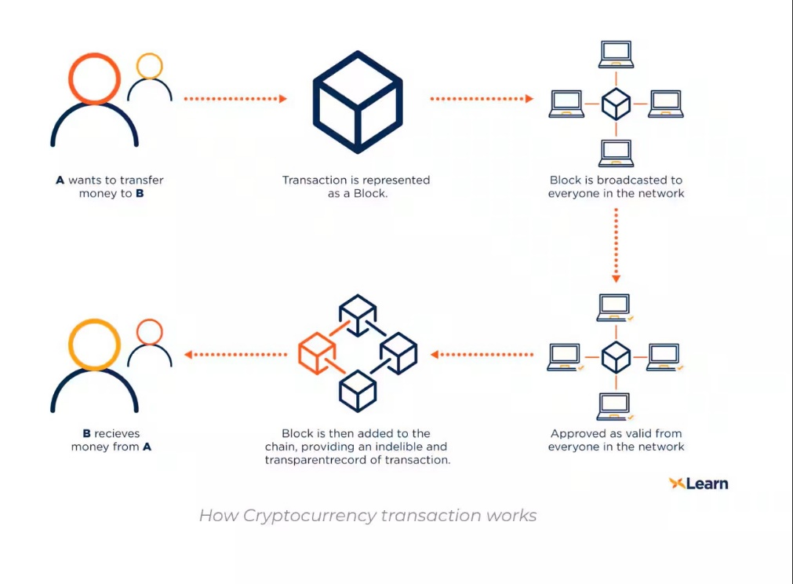
\

Fig 2: Transaction in Cryptocurrency

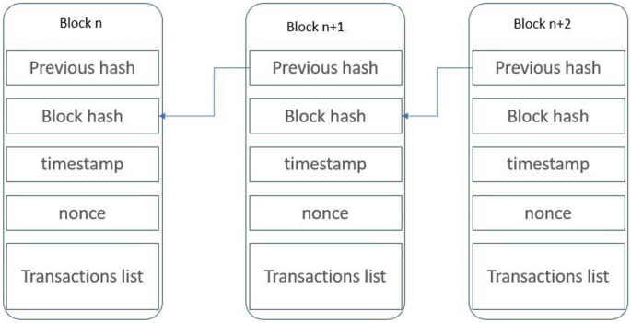

Fig 3: Block Structure

Algorithms & Implementation

Blockchain technology relies on a variety of mathematical functions and algorithms rooted in cryptographic principles and data management techniques. The following mathematical concepts and algorithms are essential for ensuring the security, integrity, and efficiency of blockchain applications in finance beyond cryptocurrency:

- Cryptographic Hash Functions

  - Definition:
Cryptographic hash functions convert input data into a fixed-length character string, ensuring uniqueness for the given input.

  - Formula:
H(x) produces a unique hash for input x

  - Key Properties:
- Deterministic: The same input yields the same hash output.
- Pre-picture Resistance: tough to reverse the hash to discover the authentic input.
- Collision Resistance: difficult to find two one of a kind inputs with the identical hash output.

- Public Key Cryptography:

  - Definition:
Public-key cryptography uses a couple of keys: a public key (shared overtly) and a private key (kept secret).

  - Formula:
Public Key: PK, Private Key: SK

  - Key Properties:
- Secure Communication: Only the intended recipient can decrypt the message.
- Digital Signatures: Ensures authenticity and integrity of messages.

- Quantum-Resistant Algorithms:

  - Definition:
Quantum-resistant algorithms are designed to at ease facts in opposition to capacity threats from quantum computers.

  - Example Algorithms:
RSA (Rivest-Shamir-Adleman) and ECDSA (Elliptic Curve virtual Signature set of rules)
  - Key Properties:
- Hard Mathematical Problems: Based on problems believed to be challenging for both classical and quantum computers.
- Diversity of Algorithms: Include lattice-based, hash-based, and multivariate polynomial approaches.

- RSA (Rivest-Shamir-Adleman):

  - Definition:
RSA is an asymmetric cryptographic algorithm that uses the mathematical properties of prime factorization to provide security. It relies on two keys: a public key for encryption and a private key for decryption.

  - Input:
- Two large prime numbers, ppp and qqq
- A message that needs to be encrypted

  - Output:
A digital signature that can be verified by anyone who has access to the public key.

- ECDSA (Elliptic Curve Digital Signature Algorithm)

  - Definition:
ECDSA is an asymmetric cryptographic algorithm based on the mathematics of elliptic curves over finite fields. It provides a higher level of security with smaller key sizes compared to traditional methods like RSA.

  - Input:
- An elliptic curve and a base point G
- A private key k
- A message that needs to be signed

  - Output:
A digital signature that can be verified by anyone who has access to the public key.

Summary

Blockchain technology has emerged as a key driver of innovation in the financial sector, extending far beyond its initial association with cryptocurrencies. It offers secure, decentralized solutions that can streamline processes such as cross-border payments, identity verification, and supply chain financing. With its ability to increase transparency, reduce costs, and eliminate intermediaries, blockchain has demonstrated its value across a variety of financial applications, including smart contracts and digital asset management. Despite these advancements, challenges such as regulatory uncertainty, technical scalability, and the need for global standards remain significant barriers to widespread adoption. These complexities make it clear that blockchain’s full potential in finance is still being explored.

Conclusion

While blockchain holds the promise to revolutionize financial services by enhancing efficiency and trust, its future hinges on overcoming key challenges. Addressing regulatory and technical hurdles, such as interoperability and scalability, will be crucial for blockchain’s successful integration into mainstream finance. Additionally, ethical concerns related to privacy, data security, and inclusivity must be thoughtfully managed to ensure responsible use. Continuous collaboration among policymakers, industry leaders, and researchers is essential to refine the technology and establish clear frameworks that support secure and scalable blockchain solutions. With sustained effort, blockchain can become a transformative force, creating more resilient, transparent, and equitable financial systems.

References

- Chen, Hanfang, et al. "The Role of Blockchain in Finance Beyond Cryptocurrency: Trust, Data Management, and Automation." IEEE Access (2024).
- Bhutta, Muhammad Nasir Mumtaz, et al. "A survey on blockchain technology: Evolution, architecture and security." Ieee Access 9 (2021): 61048-61073.
- Ozcan, Sercan, and Serhan Unalan. "Blockchain as a general-purpose technology: Patentometric evidence of science, technologies, and actors." IEEE transactions on engineering management 69.3 (2020): 792-809.
- Dos Santos, Saulo, et al. "A new era of blockchain-powered decentralized finance (DeFi)-a review." 2022 IEEE 46th Annual Computers, Software, and Applications Conference (COMPSAC). IEEE, 2022.
- Amler, Hendrik, et al. "Defi-ning defi: Challenges & pathway." 2021 3rd Conference on Blockchain Research & Applications for Innovative Networks and Services (BRAINS). IEEE, 2021.
- Leng, Jiewu, et al. "Blockchain security: A survey of techniques and research directions." IEEE Transactions on Services Computing 15.4 (2020): 2490-2510.
- Jie, Wanqing, et al. "A Secure and Flexible Blockchain-Based Offline Payment Protocol." IEEE Transactions on Computers (2023).
- Wang, Bin, et al. "DeFiScanner: Spotting DeFi attacks exploiting logic vulnerabilities on blockchain." IEEE Transactions on Computational Social Systems 11.2 (2022): 1577-1588.
- Li, Zecheng, et al. "Securing deployed smart contracts and DeFi with distributed TEE cluster." IEEE Transactions on Parallel and Distributed Systems 34.3 (2022): 828-842.
- Javed, Ibrahim Tariq, et al. "PETchain: A blockchain-based privacy enhancing technology." IEEE Access 9 (2021): 41129-41143.

Plagarism Report
